Jared Dyreson

Professor Joseph Oliva

Physics 101

21 February 2018

Electromagnetic Spectrum

One way for energy to move through a vacuum is in the form of electromagnetic waves. These waves range in size depending on how long their periods are which is the time it takes for one cycle of movement to be completed. This scope lies on what physicists call a spectrum. Electromagnetic waves differ from sound waves as they do not rely on the change in air pressure that sound waves do. Much like its counterparts of sound and water, E.M waves can also transport energy from one place to another. For example, this allows the heat energy from the Sun to make it to Earth with manipulating matter along the way.

The components of an E.M wave are quite simple as they are made of atomic particles that are excited by an electric field. When moving, these groups of moving particles are called a photon which can move at an incredible speed of 186,000 miles per hour. It’s structure is similar to that of a wave in the ocean as it has a high and a low, much like a sine or cosine graph. It’s oscillating behavior can be easily mapped with the formula **v = f\*ƛ** where the first character is velocity. It is equal to the frequency of the wave by the wavelength of the wave which is denoted by the Greek symbol lambda.

The frequency of E.M waves are inversely proportional with the wavelength meaning if the wavelength increases, the frequency would decrease. For example, a radio has a large wavelength as it is able to cover a large distance while retaining its strength however it has a small frequency or the amount of oscillations completed in a given time. With this formula, it is possible to find out various characteristics of a given wave such as speed, time it takes to complete one single oscillation, etcetera.

In the middle of the E.M wave spectrum lies the frequency of light that humans perceive as color. Every other form of light cannot be seen by the naked eye but can be observed in other ways. For example, doctors will use X-Rays to see the bones of patients to address fractures or breaks in their bones but we cannot see the waves going into their body. Another would be the heat you feel from the sun. Yes we can see the visible light but what gives us warmth are the infrared waves emanated.

Unlike a physical wave made of water, E.M waves can transport energy without moving tangible objects.

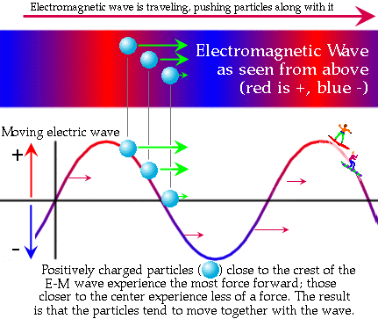 This picture illustrates that the positively charged particles falling down a slope of the electromagnetic wave, accumulating momentum and being shot back up to the peak of the slope. This is a continuous process until there is no more energy left in the wave.

Electromagnetic waves are non-tangible waves that carry energy from one place to another and are comprised of excited atomic particles called photons. Much like sound waves, E.M waves vary in size depending how long it takes to complete one complete cycle and are indirectly proportional with the wavelength. With a wide variety of sizes of period lengths allows for different functionality of light in the natural world.